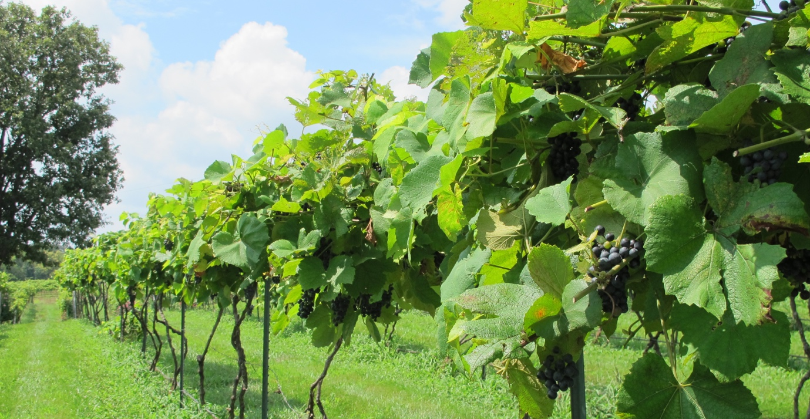

MISSOURI WINEMAKING SOCIETY NOVEMBER 2023 NEWSLETTER

NEXT MEETING: FAVORITE RED WINE CONTEST
November 16, 2023
WHERE:
St. Gerard Majella Meeting Room
1969 Dougherty Ferry Rd. Kirkwood, MO. 63122
TIME:
7:00 PM
SUBMITTED BY:
Lisa Nordmann

NOVEMBER MEETING – FAVORITE HOME CRAFTED RED WINE CONTEST
Favorite Home-Crafted Red Wine. The meeting offers an opportunity to share a bottle of your red home-made wine with other winemakers and receive feedback. It is one of the most anticipated meetings of the year where we enjoy blind tasting our member’s wine and then vote for our personal favorites. Each member who would like to participate should bring one bottle to share at ready to serve temperature. Wine can be made from grapes or other fresh fruit, juice-fresh or frozen, or concentrates as in wine kits. If you have added any commercial wine in topping up your carboy or bottle, your wine is not eligible for the Favorite Wine Contest.
Please be prepared to verbally share how you made your wine at the end of the tasting. All members are encouraged to attend this meeting even if they do not have a wine to share.

RECAP OF THE OCTOBER PICNIC
Dan and Jeanine Peters graciously hosted our October “indoor” picnic. The Halloween theme was very festive. Dan and Jeanine went above and beyond the call of duty with the delicious smoked brisket and grilled chicken which were mouth watering. The side dishes and desserts provided by members were delectable. And Mr. Meowski’s cookies did not disappoint. Dan and Jeanine provided 14 bottles of wine that we blind tasted. The trick was to identify what varietal and what country it came from. It was very hard but there was a winner. The big winner was Brian Prunty and Deb Rahn was the runner up. Congratulations to the winners!
Later on, some of us braved the cold and gathered around the outdoor fire, continuing drinking delectable homemade wines provided by members.
A wonderful time was had by all!

PRESIDENT’S MESSAGE: by Dan Peters
Hello MWS : Our year has officially reached its crescendo. For October, we enjoyed our annual picnic at our house. Subpar weather did not keep us down. We moved some furniture; had fun with a 14 international wine game; enjoyed lunch; and headed outside for frivolity around a camp fire. Fun had by all. Thank you to Musto Wine, and Lisa Nordmann, several of us picked up a wide variety of grapes and juice from CA and elsewhere last weekend. Of course, that means a week of hauling, crushing, testing, fermenting, pressing etc. For many, this week also brings the American Wine Society National Conference in downtown St. Louis. Let’s keep it going – This month we will join for a fan favorite – Favorite Red Wine – so brush off one of your treasured red wines to share 11/16. That will wind down our shall I say “business” meetings for the year, as we finish the year with our Holiday party at the Wert’s Home. OMG, I’m worn out now.

MUSTO GRAPE/JUICE PICKUP
Our Musto grapes/juice pickup went well on a cold and rainy Sunday. 8 members and 1 non-member purchased grapes from Musto Grapes. The grapes came in excellent condition and now, all are happily fermenting. The juice pails came slightly fermented, which I am believing is the nature of the beast. Musto gave us a wonderful price. I am hoping to have this become a yearly buy from them. They were very easy to work with and were very accommodating. Now is a good time for us to start thinking about what wines (besides Missouri) we would like to make next year.

FUTURE MEETINGS FOR MWS
The officers will be meeting in January to plan our yearly meetings. The officers would like to hear from you on what meetings you would like. Steve Brunkhorst had us fill out a survey in 2022. The top meetings were as follows:
- Local Winery Visit
- Christmas Party
- Fall Picnic
- Missouri Gold Medal Winners (Wine Tasting of the winners)
- Favorite Home Crafted White Wine Contest
- Favorite Home Crafted Red Wine Contest.
That leaves us with six meeting slots to fill. Other suggestions are as follows:
- Advanced Winemaking Topics
- Troubleshooting Wine Problems and Wine Faults
- MWS Winemaking Project
- Making Norton Wine
- Anything but Missouri Wine Making
- Invited Guest Speaker (winemaker from a local winery)
- Additives to Wine
- Winemaking Fundamentals
- Grape Growing and Vineyard Management – Including Troubleshooting Vineyard Issues
- Making a Wine as a Team
- Making a Port Wine
- Fruit Winemaking
Please bring your ideas to the November meeting where we will take a preliminary count on the top meeting choices. Let us also know if you would like to lead a presentation.

MISSOURI AMATEUR WINEMAKERS FACEBOOK PAGE
Lisa Nordmann has started a Facebook Group called Missouri Amateur Winemakers. It is a group of Missourians sharing their experience as winemakers. She is hopeful that the members who join can help each other in making great wines. This will be a place where we can exchange ideas, sell or buy equipment, and see what vineyards are selling grapes. We amateur winemakers grow better from the information that we receive from one another. No winemaker is an island. Please join and we can help each other out. Here is the link to join:
https://www.facebook.com/groups/270035898745586/?multi_permalinks=270775995338243&notif_id=1685996531246939&notif_t=feedback_reaction_generic&ref=notif

Remember to join our Facebook Page, Missouri Winemaking Society and our Instagram Page, Missouri Winemaking Society. The more we learn from each other when we share our winemaking skills on our social media pages.

ENJOY THE PICS FROM OUR OCTOBER PICNIC

