MISSOURI WINEMAKING SOCIETY
NOVEMBER 2021 NEWSLETTER

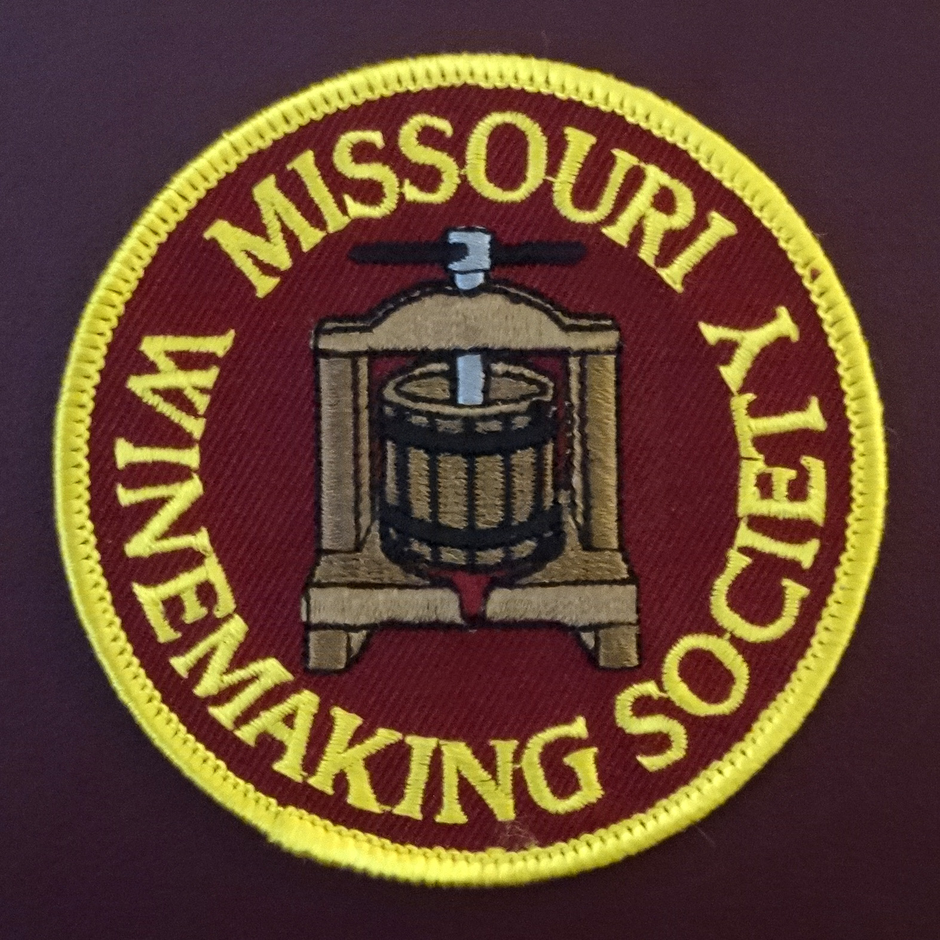

IN THIS NEWSLETTER:
- FAVORITE RED TASTING, Thursday November 16th 7PM
at St. Gerard Majella Parish
- PRESIDENT’S MESSAGE
cheap carboys…not worth the money saved…
- NOMINATION FOR OFFICERS FOR YEAR 2022
Election to be held at November meeting
- MEETING SCHEDULE FOR 2021
Christmas Party at John & Mary Merkle’s, Vaccination required
- OCTOBER PICNIC RECAP
The weather cooperated for an ideal picnic day…
- ODDS AND ENDS

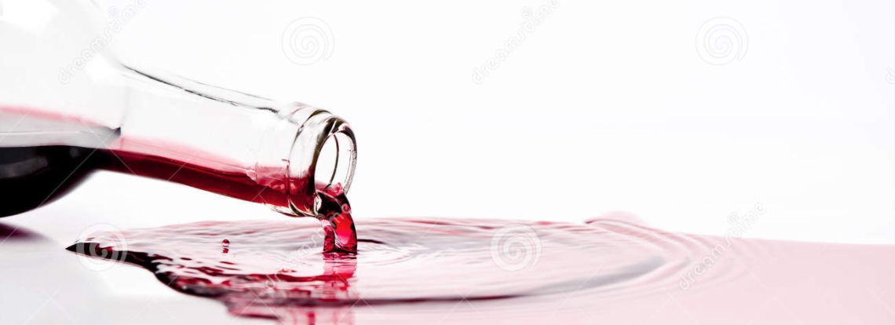
NOVEMBER BRINGS BACK AN IN-PERSON-MEETING at St Jerard Magella Parish on Dougherty Ferry Rd. The tasting topic is Favorite Red Wine. As in past years, each winemaker can bring ONE bottle of red wine he or she would like to share at proper serving temperature. Each bottle will be place in a brown bag by the cellar master so that the maker’s identity is concealed. Worksheets will be provided to all tasters to record tasting notes. After tasting all wines each taster will vote by secret ballot for his or her 3 favorite wines. The votes will be tallied, and results revealed. Winemakers will then discuss their wine with the tasters. The Favorite Red Winemaker will be recognized with a small but elegant trophy.
COVID CONSIDERATIONS: MWS Officers have decided that attendees must be vaccinated to attend this indoor event. Masks will be required except when seated tasting wine. Each attendee is asked to bring his or her own glass. This protocol is consistent with many ticketed public gatherings and restaurants in the St Louis area. MWS Officers will continue to monitor best practices and adjust future meeting protocol when appropriate.
PRESIDENT’S MESSAGE. By Lisa Nordmann
I belong to several winemaking groups on Facebook, as I am sure many of you do too. Each morning I quickly peruse the groups to see if anything grabs my attention. Last week something about glass carboys breaking at the base definitely caught my attention.
I have never had a carboy break just sitting there minding its own business filled with wine. However, I did break one empty carboy as it slipped out of my hands and shattered in several pieces on the floor. Does the shattering of a carboy bring back bad memories for any of you?
On this Facebook page, the members talked about carboys breaking at the base. One member posted this informative Youtube video explaining the difference between a carboy made in Italy and other cheaper carboys made elsewhere. Here is the link to the Youtube video. The Hidden Reason Glass Carboys are Shattering Suddenly (and How to Avoid It)
The Hidden Reason Glass Carboys are Shattering Suddenly (and How to Avoid It) - YouTube
I found this video very enlightening. Now I am obsessing each day, hoping the bottom will not break on any of my carboys. How many of my carboys are from Italy? How many are from Mexico and God forbid that I have any from China. I have too much time, money, and hopefully good wine to have one of these breaks. As I empty these carboys into barrels and bottling, I will definitely check to see if any of my carboys will need to be sent to recycling.
According to the Youtube video, Italian carboys are best. They are a few dollars more than their counterparts but are made of a higher quality glass and are known for their overall strength and uniform thickness.
Buying cheap carboys is definitely not worth the money saved.
Cheers! Lisa

OFFICERS FOR 2022. The following members were nominated at the October 16th picnic-meeting to serve as officers for calendar year 2022: President: Lisa Nordmann, Vice President: Brian Prunty, Treasurer: Phil Rahn, Secretary: Steve Brunkhorst, Cellar Master: Dan Peters. There was a call for nominations from the floor, no additional nominations were received. The vote for the 2022 officers will be held at the November meeting. John Merkle will finish his term as Cellar Master in December, thanks John for your service to MWS!

2021 MEETING SCHEDULE. Please mark your calendar for the 3rd Thursday of each month at 7PM. The Current plan through January 2022 is shown below. Note the December meeting is our annual Christmas party on Saturday December 11th. Check our website for real time updates of the MWS calendar: https://www.mowinemakers.org/
January 21 • 7:00 PM • Speaker • Andrew Meggitt - St. James Winery
February 18• 7:00 PM • Speaker • Kevin Kourofsky • Judge Judy Kelly • Make Better Wine
Marc
h 18 • 7:00 PM • Speaker • Hildegarde Heymann, Ph. D. Enologist UC-Davis
April 15 • 7:00 PM • Speaker • Jacob Schneider - Cane Pole Vineyards, LLC
May 20 • 7:00 PM • GADs & GIZs • John Merkle & MWS members
June 17 • 6:30 PM • Lisa & John Nordmann’s Home • Rose’ Winemaking Project
July 17 • 11:00 AM • Defiance Ridge Winery Tour and Picnic • MWS Members • Purchase Wine and Food there.
POSTPONED August 19 • 7:00 PM • Thursday • St. Gerard Majella • Program • Grape growing in Missouri, is Organic Possible? • Presenter • Terry Stromberg
August 19 • 7:00 PM • Thursday • ZOOM • Program • Winemaking 2021, grapes, fruit, juice, plans • Presenter Lisa & Officers & Members
September 16 • 7:00 PM • Thursday • St. Gerard Majella • Favorite White Wine Contest • Leaders • Steve Brunkhorst and Phil Rahn
September 16 • 7:00 PM • Thursday • ZOOM • Program • Wine Competitions • Leader • Greg Stricker
October 16 • Noon • Saturday • Dave & Debbie Wert’s Home • Annual MWS Picnic • MWS Members Potluck
November 18 • Thursday • 7:00 PM • St. Gerard Majella • Favorite Red Wine Contest • Leaders • Steve Brunkhorst & Phil Rahn
December 11 • Saturday • 6:00 7:00 PM • John & Mary Merkle’s Home • Christmas Party • MWS Members Potluck
January 20, 2022 • Thursday • St. Gerard Majella • Missouri Gold Medal Winning Wines
RECAP: OCTOBER 16th PICNIC at DAVE & DEBBIE WERT’S. There was delicious food, an abundance of well-crafted wine, and long-time and new winemaking friends galore. There was also a “mystery-wine-tasting” including award winning and faulted wines. Our senses were treated to (or subjected to) a spectrum ranging from “dry white” to “wet dog”. Many thanks to Dave and Debbie for opening their home and their vineyard for this event.
ODDS & ENDS:
Jerry Parker, a former member of Missouri Winemaking Society has generously donated items for our members and a couple remain available. They are FREE and being stored at Lisa Nordmann's house. Here are the remaining items: one 5-gallon carboy, 4 oz Oak Chips, 10kg French Oak Chips, Thank you Jerry! Contact Lisa Nordmann at lnordmann@sbcglobal.net
**********************************************************
Lisa Nordmann writes: IF ANYONE IS INTERESTED in purchasing some FT CITRUS (Scott Labs) please e-mail me at lnordmann@sbcglobal.net. I had to buy 2 1/2 pounds and would like to get rid of some. FT CITRUS is not sold anywhere in smaller quantities. Here is the link from Scott Lab. https://shop.scottlab.com/ft-blanc-citrus-ftblancct?returnurl=%2fsearch%3fq%3dft%2bblanc%2bcitrus

************************************************************
NOTE This ODDS & ENDS spot open to members. If you have equipment to sell or give away or just something of interest you would like to share, email it to Steve Brunkhorst for inclusion here.

