MISSOURI WINEMAKING SOCIETY
MARCH 2021 NEWSLETTER

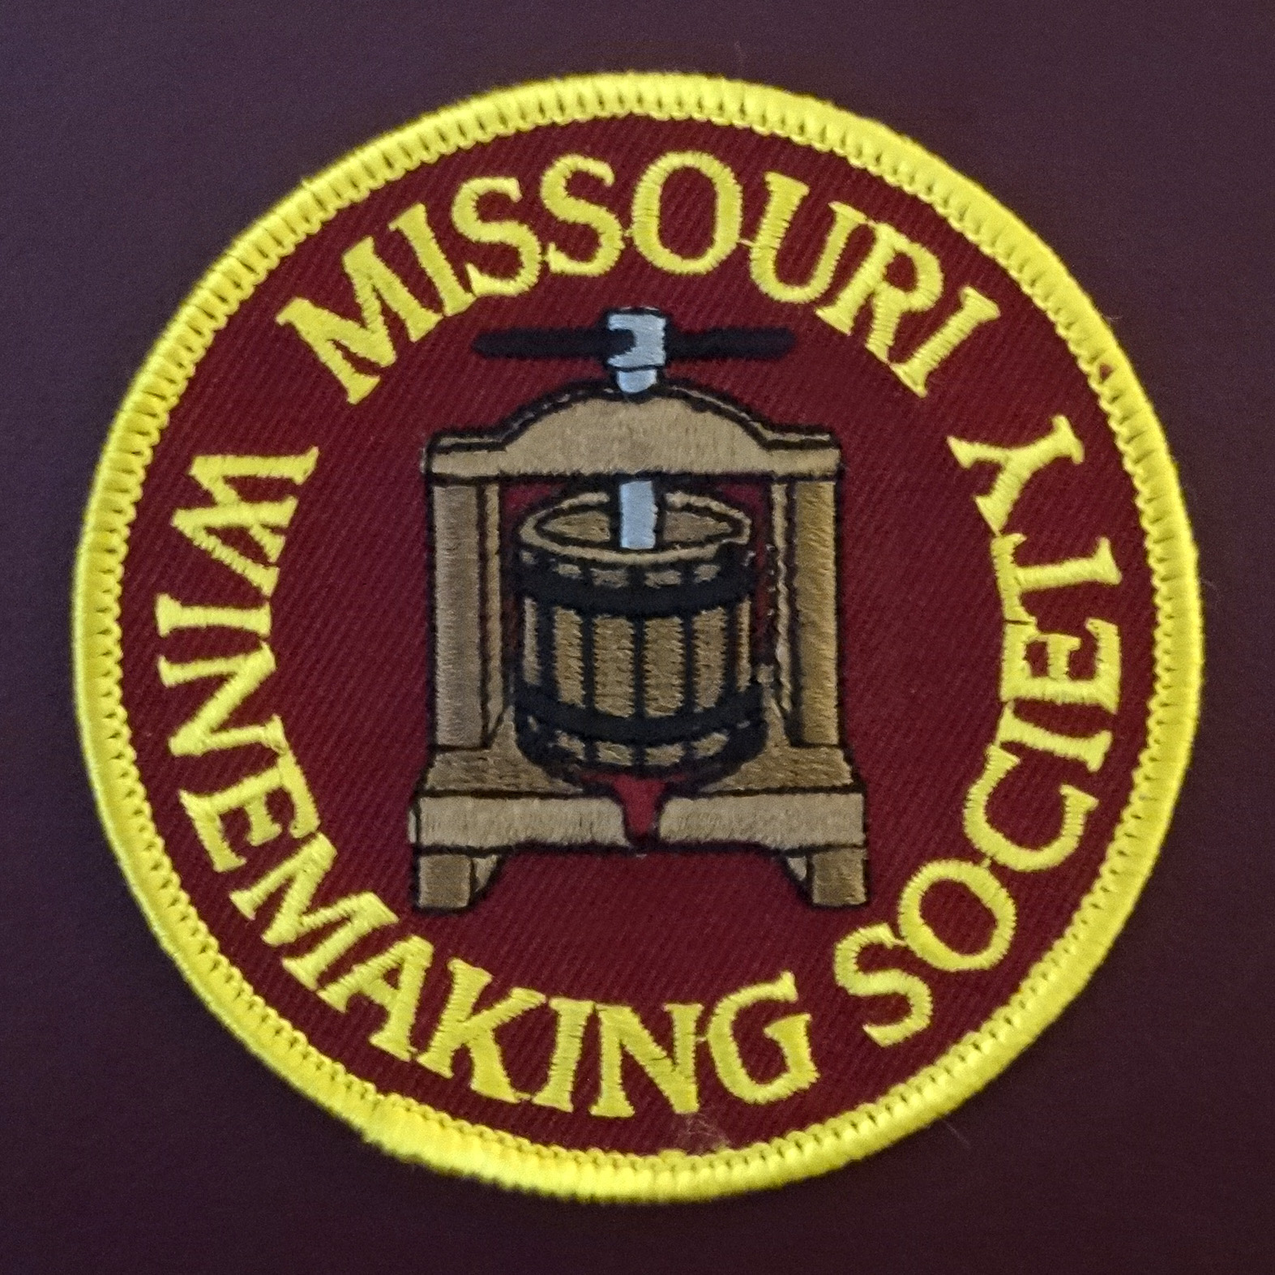

IN THIS NEWSLETTER:
- MARCH ZOOM – Thursday, 3/18 at 7PM
- PRESIDENT’S MESSAGE
- DUES DUE - SPECIAL COVID RATES
- MEETING SCHEDULE FOR 2021
- FEBRUARY MEETING RECAP
- ODDS AND ENDS

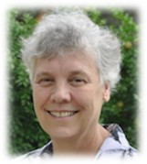
Our March meeting presents a once in a lifetime opportunity for you to finally “Come to your Senses”. We are privileged to have Dr. Hildegarde Heymann, Ph.D., Distinguished Professor of Sensory Science in the Department of Viticulture and Enology, UC-Davis as our meeting leader. She will take us on a colorful visual tour of our human senses and explain their relationship to our sensory perception and evaluation of wine. Along the way you will discover just how likely you are to be a “super-taster” … and, what in the world does that mean anyhow. If you miss this meeting, you may find you have “Lost your Senses”, and please, don’t do that! A ZOOM link will be sent to your email address the day before the meeting.

Dr. Hildegard Heymann
Hildegarde Heymann is a Distinguished Professor of sensory scientist in the Department of Viticulture and Enology, University of California—Davis. She received a BSc Agriculture degree from the University of Stellenbosch, South Africa and an MS and PhD degree from the University of California—Davis. She was a faculty member at the University of Missouri and has been at Davis since 2003. Hildegarde focuses on sensory evaluation of alcoholic beverages and the use of multivariate statistics to integrate sensory and chemical/instrumental data. She and Harry Lawless are the authors of Sensory Evaluation of Food: Principles and Practices. She also co-authored with Susan Ebeler: Sensory and Instrumental Evaluation of Alcoholic Beverages. She has published over 135 peer-reviewed articles.
PRESIDENT’S MESSAGE. By Lisa Nordmann
Raise a glass to our Missouri Winemaking Society’s Women! March 8th marks International Women’s Day, with the entire month of March celebrating Women’s History Month. This celebration of women has been shared in some form dating back to 1911. In February 1980, President Jimmy Carter issued a presidential proclamation declaring the week of March 8, as National Women's History Week.
Missouri Winemaking Society would like to honor our women members. Maggi Brunkhorst, Anne Cath, Heidi Hehner, Judy Hon, Mary Kalish, Sally Kintz, Lisa Nordmann, Teresa Prunty, and Debbie Rahn.
These women are supportive wives, wine tasters, grape growers, and winemakers. For the first time in the history of Missouri Winemaking Society, we have 10 amazing women members. Thank you all for your input and support.
Editor’s note: Lisa, our 1st Woman President is an award winning winemaker.
DUES ARE DUE NOW. If you paid for a $50 membership in 2020, your 2021 dues are just $15. If you did not pay for a $50 membership in 2020, your 2021 dues will be just $30. Send your check payable to “Missouri Winemaking Society” to Phil Rahn, 511 Kenilworth Ln, Ballwin, MO 63011. Dues were due by end of January but are still being accepted. Dues Background: 2021 dues have been set to cover only the “fixed costs” of our society since we do not know exactly when we will be able to meet again face to face. In addition, our variable costs in 2020 were less than budgeted due to suspension of meeting and the substitution of ZOOM events, so the remainder of dues not spent in 2020 have been applied to 2021 fixed costs.
2021 MEETING SCHEDULE. Please mark your calendar for the 3rd Thursday of each month at 7PM. We will begin the year with a continuation of the ZOOM meetings. We hope that Covid-19 will be under control later in the year and we will be able to resume in person meetings at St. Gerard Magella Church. The officers are working to finalize the schedule for the remainder of the year to be published in the monthly newsletter and on our website: https://www.mowinemakers.org/
January 21 • 7:00 PM • Speaker • Andrew Meggitt - St. James Winery
February 18• 7:00 PM • Speaker • Kevin Kourofsky • Judge Judy Kelly • Make Better Wine
March 18 • 7:00 PM • Speaker • Hildegarde Heymann, Ph. D. Enologist UC-Davis
April 15 • 7:00 PM • Speaker • Jacob Schneider - Cane Pole Vineyard
May 20 • 7:00 PM • Gadgets & Gismo’s • Share your favorite.
June • Winery Tour Defiance Ridge • to be discussed at March meeting
July - November - to be determined due to Covid-19
December • Annual Christmas Party
THE FEBRUARY MEETING was as a ZOOM event on Thursday, February 18th led by AWS-Wine-Judge Judy Kelly and Grape Grower/Winemaker Kevin Kourofsky, both from Rochester NY. In this very enjoyable and educational event, Judy explained what she looks for when judging and Kevin discussed wine making techniques to help us make award winning wines. Thank you, Judy and Kevin.
ODDS & ENDS: This spot open to members. If you have equipment to sell or give away or just something of interest you would like to share, email it to Steve Brunkhorst for inclusion here.

