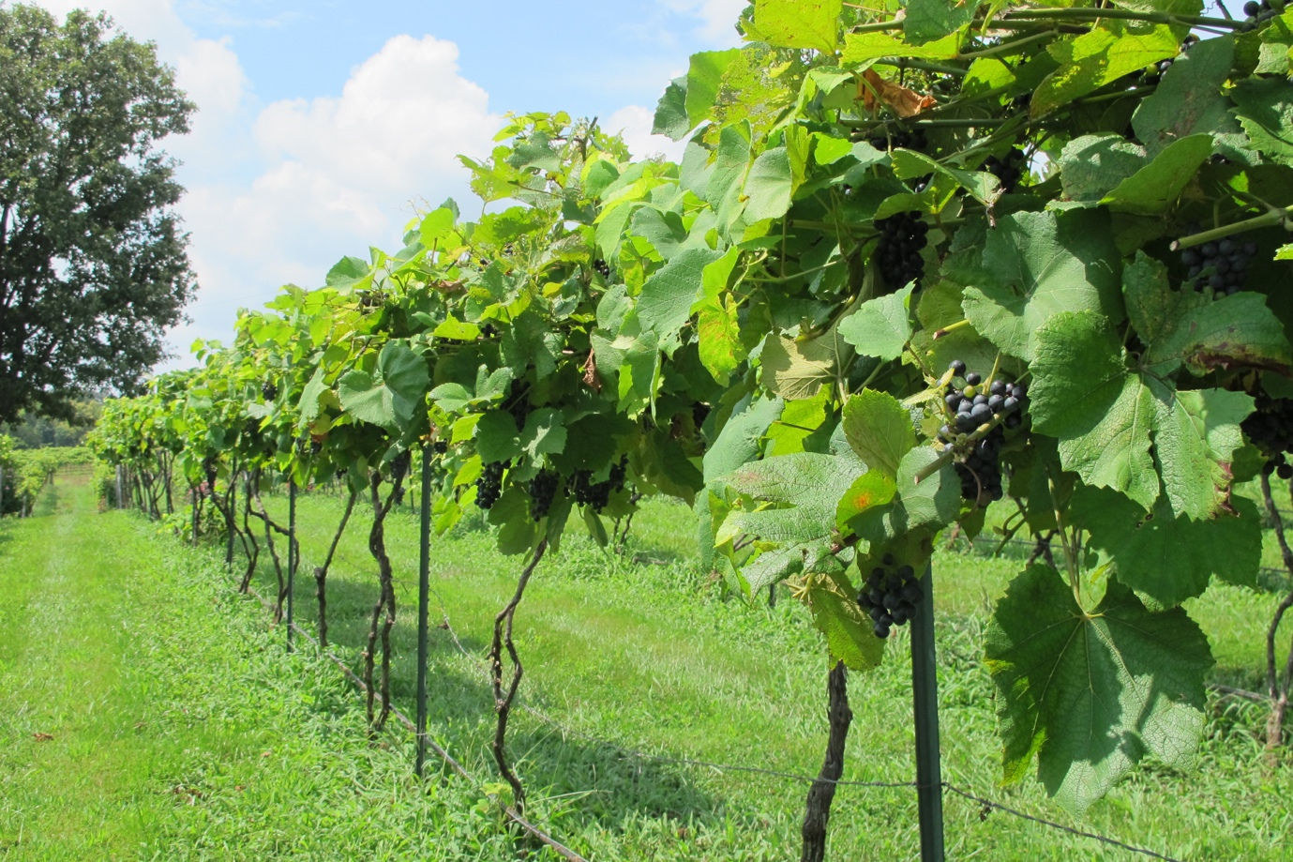

**MISSOURI WINEMAKING SOCIETY JANUARY 2024 NEWSLETTER**

**NEXT MEETING: MISSOURI GOLD MEDAL WINNERS TASTING**

**DATE: THURSDAY, JANUARY 18**

**WHERE: ST. GERARD MAJELLA MEETING ROOM**

**1971 DOUGHERY FERRY RD.**

**ST. LOUIS, MO 63122**

**TIME: 7:00 PM**

**MWS WEBSITE:** [**www.mowinemakers.org**](http://www.mowinemakers.org)

**MWS FACEBOOK PAGE**: Missouri Winemaking Society

**MWS INSTAGRAM PAGE**: @mowinemakingsociety

**MISSOURI AMATEUR WINEMAKERS FACEBOOK PAGE**: Missouri Amateur Winemakers

**SUBMITTED BY: Lisa Nordmann**

**PRESIDENT’S MESSAGE**: **by Dan Peters**



Happy New Year’s to All!!! We will follow a great 2023 with a superb 2024. The officers will be meeting next week to plan out the 2024 programs. We have many programs in the works from many of our members suggestions. Looking forward to seeing you soon!

**JANUARY MEETING: Missouri Gold Medal Winners Tasting**

Steve Brunkhorst will present the Missouri Gold Medal Winners with a tasting of some of these fine wines. Presently, among the wines to be tasted are a 2022 Bobby Sue’s Dry Chambourcin Rose’ from Defiance Ridge. A Signature Port from Adam Puchta and a St. James 2022 Explorer Semi Dry Vignoles. We are still in the process of procuring wines for this highly anticipated meeting.

**YEARLY DUES ARE DUE**

Our yearly dues of $50 is now due. Please bring a check made out to Missouri Winemaking Society to the January meeting and give it to Dave Wert. You can also mail it in to Dave Wert, 1599 Highway 100, Pacific, MO 63069.

**ST. JAMES CELLAR HANDS LUNCH AND DISCUSSION**

On Friday, January 26th at 11:30, we will be meeting with the Cellar Crew from St. James Winery at the Public House, (right next door to St. James Winery) and will have lunch and discuss our wines. They would love to taste our wines made from St. James juice and also any other home crafted wine you would like to share. The Cellar Crew will be giving us their professional opinion on our wines. As all of you might know, we are the only club that St. James sells to in small lots. They do a lot for us by filling our small buckets, give us a stat sheet and answer any question we may have. And not to say how accommodating they are in meeting with us at different pickup times. I would like to ask for volunteers to help pay for their lunch. I am not sure at this time how many Cellar Crews will be in attendance but I thought it would be a nice gesture since St. James does so much for us. Please e-mail me at [lisanordmann121@gmail.com](mailto:lisanordmann121@gmail.com) if you will be in attendance and if you are willing to help defray the cost of their meals.

**RECAP OF OUR ANNUAL CHRISTMAS PARTY**

Debbie and Dave Wert graciously hosted our annual Christmas party at their house. The house was very festive with the wonderful Christmas decorations that put us all in the Christmas spirit. The food was delicious, especially Debbie and Dave’s homemade lasagna and rolls. Everyone brought a side dish and deserts that all were delectable. We started the evening off with several sparkling wines and many members shared their wonderfully handcrafted wines. We ended the evening with several ports that were divine. The best part of the evening was the friendship we have made and continue to share.

