MISSOURI WINEMAKING SOCIETY
JUNE 2021 NEWSLETTER

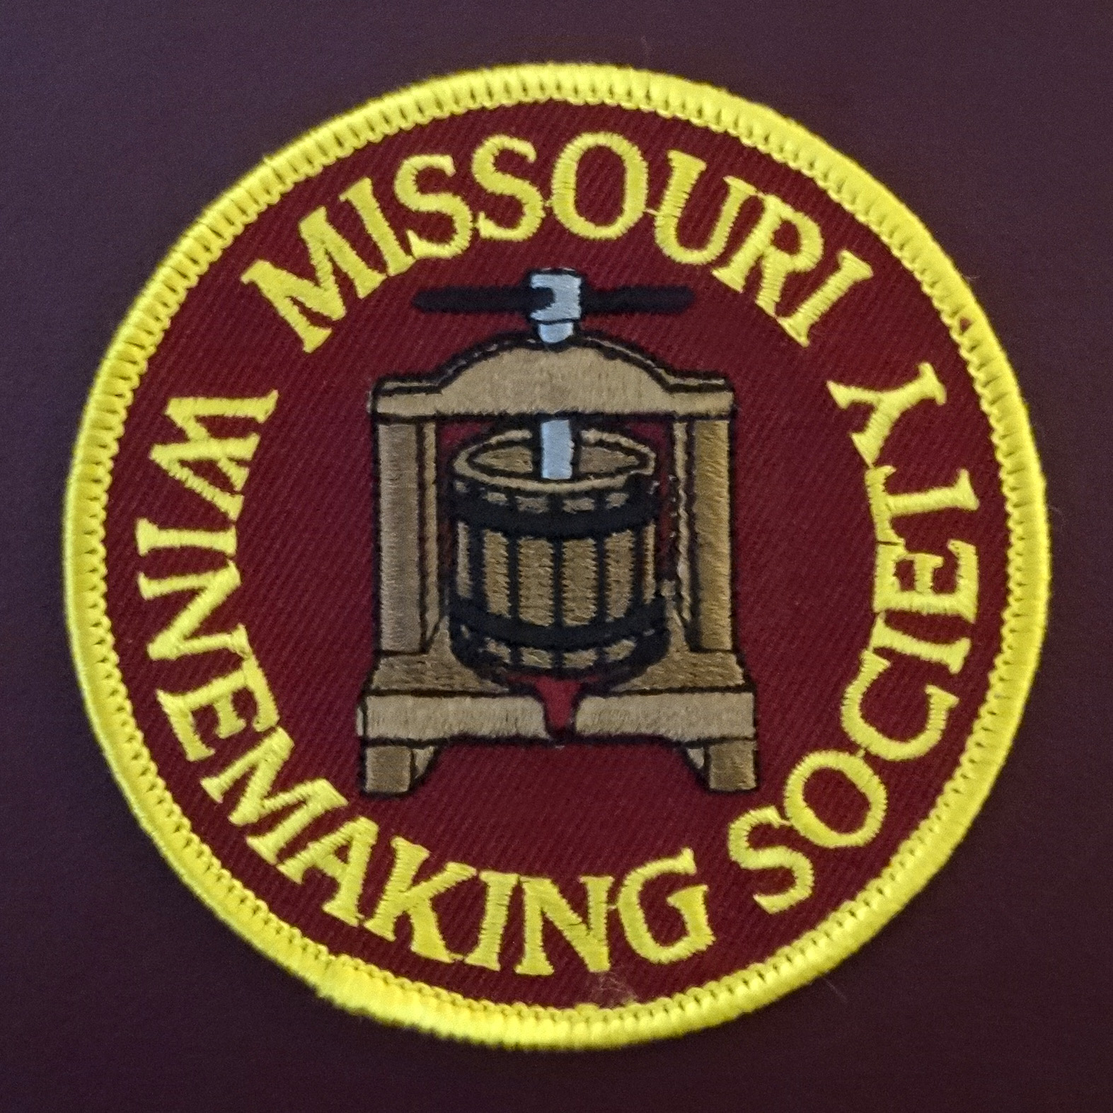

IN THIS NEWSLETTER:
- JUNE-In Person MEETING – Thursday, 6/17 at 6:30PM
Rose’ Project
- PRESIDENT’S MESSAGE
Silver Linings
- MEETING SCHEDULE FOR 2021
In-person meeting resumes this month (outdoors)
- APRIL MEETING RECAP
GADs and GIZs, we saw many…
- ODDS AND ENDS
It is Free to a good home! A pretty kitty? No, a 54 liter D………

ROSE’ PROJECT: This month we will resurrect our 2019-2020 Rose’ winemaking project organized by Steve Brunkhorst (me). The project was launched mid-year 2019 with a plan to taste the wine sometime in 2020.
Twelve of our 2019 members signed up for this project and I have heard from eight who will bring wine to our June tasting. (Steve, Cris, John, Dan, Phil, Greg, Terry, and David). Thank you.

The meeting will be held outside at John & Lisa Nordmann’s home. The meeting will begin at 6:30PM (half hour earlier than normal) so that we can finish before dark. We need 8 attendees to bring chairs, so “if you got ‘em bring ‘em”. The Nordmann’s home is at 121 Park Lawn Estates, Fenton MO, 63026. Phone: 314.608.8886.

The Rose’ tasting will be blind. Attendees will vote for their favorite Rose’ and results will be tabulated and announced at the end of the tasting. After wines are tasted, winemakers will be asked to give a few-minute-explanation of their winemaking process.

WINE NOTE: Rose’ wines are most often consumed the year after the harvest vintage for a few couple of reasons. Dry Rose’ wine does not have significant tannin or residual sugar or elevated alcohol, so the shelf life is typically a few years. Also, wineries can offer this product in the spring which allows them to generate some cash very soon after fermentation. It will be interesting to see how our homemade Rose’ wines from 2019 (or earlier) have held up.

BACKGROUND: Project participants were asked to produce a still, dry (<1% Residual Sugar) Rosé wine. The project allowed wines to be made from fresh grapes or juice or frozen Rosé juice. Grapes or juice could be from Missouri or outside of Missouri such as California or Illinois.

If using grapes, the Rose’ wine was to be made by one of three processes: 1) Limited Skin Maceration 2) Direct Pressing, or 3) Saignee process. If using frozen rose’ juice, it could be used just as shipped by Peter Brehm or another other supplier. The choice of yeast was totally up to the winemaker.

PRESIDENT’S MESSAGE. By Lisa Nordmann
SILVER LININGS: Recently, I have been thinking a lot about the last year with Covid 19 and finding silver linings. The best silver lining, I found, was our MWS Zoom meetings and all the fantastic speakers we had.

Mike Ward – Syncopation Wines, Denny Campo – Bommarito Wines, Brandon Dixon – Noboleis Winery, Steffi Littlefield and Cyndy Keesee – Edg–Clif Winery, Andrew Meggitt, - St. James Winery, Kevin Kourofsky, grape grower/winemaker and Judge Judy Kelly, Wine Judge, Dr. Hildegard Heymann - Sensory Scientist-UC-Davis, and Jacob Schneider – Cane Pole Vineyards. All their presentations were magnificent. I am so thankful for their time and energy in educating our MWS Winemakers.

Now it is time to look ahead. I am so looking forward to our first in person meeting on June 17th at our house and tasting some great Rose’ wines. I have missed all of you so terribly. Our Zoom meetings were highly informative, but I missed our monthly interactions. I missed tasting all your great wines. I missed hearing about what you have going on in your cellar. Above all I missed seeing all of you in person.

Cheers to seeing all of you again! Lisa

2021 MEETING SCHEDULE. Please mark your calendar for the 3rd Thursday of each month at 7PM. June is our first in-person-meeting of the year, outdoors. Indoor in-person-meetings are planned to resume in August, see below. Check our website for real time updates of the MWS calendar: https://www.mowinemakers.org/
January 21 • 7:00 PM • Speaker • Andrew Meggitt - St. James Winery
February 18• 7:00 PM • Speaker • Kevin Kourofsky • Judge Judy Kelly • Make Better Wine
March 18 • 7:00 PM • Speaker • Hildegarde Heymann, Ph. D. Enologist UC-Davis
April 15 • 7:00 PM • Speaker • Jacob Schneider - Cane Pole Vineyards, LLC
May 20 • 7:00 PM • GADs & GIZs • John Merkle & MWS members
June 17 • 6:30 PM • Thursday • Lisa & John Nordmann’s Home • Rose’ Project • Presenter • Steve Brunkhorst & Phil Rahn and Rose’ Winemakers
July 17 • 11:00 AM • Defiance Ridge Winery Tour and Picnic • MWS Members • Purchase Wine and Food there.
August 19 • 7:00 PM • Thursday • St. Gerard Majella • Program • Grape growing in Missouri, is Organic Possible? • Presenter • Terry Stromberg
September 16 • 7:00 PM • Thursday • St. Gerard Majella • Favorite White Wine Contest • Leaders • Steve Brunkhorst and Phil Rahn
October 16 • Noon • Saturday • Dave & Debbie Wert’s Home • Annual MWS Picnic • MWS Members Potluck
November 18 • Thursday • 7:00 PM • St. Gerard Majella • Favorite Red Wine Contest • Leaders • Steve Brunkhorst & Phil Rahn
December 11 • Saturday • 7:00 PM • John & Mary Merkle’s Home • Christmas Party • MWS Members Potluck
January 20, 2022 • Thursday • St. Gerard Majella • Missouri Gold Medal Winning Wines
RECAP: THE MAY 20th MEETING was as a ZOOM event. The focus of the GADs and GiZs meeting was juice and wine transfer and we saw at least five different equipment items used by members to avoid lifting while preserving wine quality. Thanks to John Merkle for leading the discussion and to our member who shared their ideas and experience.

ODDS & ENDS:
Free to a good home - a 54 liter demijohn. Contact Lisa Nordmann

NOTE: This ODDS & ENDS spot open to members. If you have equipment to sell or give away or just something of interest you would like to share, email it to Steve Brunkhorst for inclusion here.

