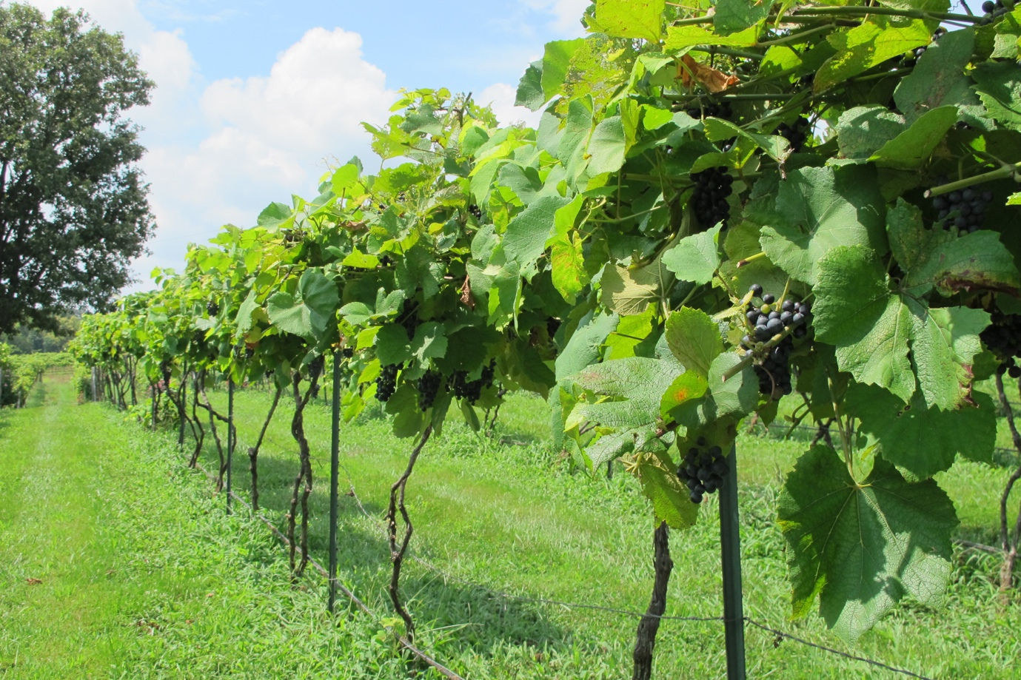

**MISSOURI WINEMAKING SOCIETY DECEMBER 2023 NEWSLETTER**

**NEXT MEETING: ANNUAL CHRISTMAS PARTY**

**December 16, 2023**

**WHERE:**

**Dave and Debbie Werts**

**1599 Highway 100**

**Pacific, MO 63069**

**TIME:**

**6:00 PM**

**SUBMITTED BY:**

**Lisa Nordmann**





**PRESIDENT’S MESSAGE**: by Dan Peters  
Happy Holidays to All!  The Holiday season offers the hope of joy for all and ( or but ) at the same time, A Lot of activity.  MWS chooses both!  Seems like yesterday we were celebrating your GREAT red wines at our Favorite Red Meeting and yet our Holiday party is already here.    
  
Hopefully all of our 2023 wines have been put to rest in carboys or barrels, with sweet, or dry, dreams of the fruity delights they will become.  As they rest, let’s celebrate our joy filled, bountiful year of wine making at the Wert’s house!    
  
Your officers will take this moment to cheer a great year but are busy considering and planning 2024.  We are thankful for the opportunity to look forward to another busy year of winemaking?    
  
Cheers!

**RECAP OF THE NOVEMBER FAVORITE RED CONTEST MEETING**

We had 3 guests attend our meeting. Steve Rosenberger who has made Norton from Jacob Schneider’s grapes and also helps Jacob hand pick his grapes. A new couple to winemaking, Paul and Penelope Sperruzza, from Eureka are hoping to learn winemaking from our group. We look forward to seeing all three at our January meeting.

Dave Anderson started the meeting off with a toast to Boujaleis Nouveau day. Greg Stricker graciously brought a bottle to be enjoyed by all. Greg was then awarded a plaque for winning the Favorite White Wine contest in July with his amazing Traminette.

Congratulations Greg!

Our favorite red wine contest meeting is always enjoyed by our members. There were 12 entries and 16 members attended. The entry bottles were all wrapped and numbered and the blind tasting began. All the wines were delicious and it was hard to blind taste these wines and come up with our favorite. Congratulations to the top winners. Bernard Cleve came in 3rd with his tasty Norton Port wine. Anne Cath came in 2nd with her delectable Syrah. And John Merkle was the big winner with his delicious Norton.

**Here are the notes from John Merkle’s Norton**



**Here are Anne Cath’s Notes for her Syrah**

Ordered 1 pail frozen must through Wine Grapes Direct November 2021.  Source was Knight’s Valley in Sonoma county CA.  I adjusted the pH from 3.06 to 3.5 with acidulated water. Used Lallzyme EX, FT Rouge, OptiRed, Fermaid K, D21 yeast.  After 5 days added opti malo plus and WLP675 (liquid malolactic bacteria). Aged with medium French oak for about a year before bottling, and another year before “releasing.”  
This was the first time I’d used a liquid malolactic bacteria mix, and the first time I really saw the MLB working.  This product is added to the fermentation when the brix is down to 5.

**Here are Bernard Cleve’s Notes for his Norton Port**

Crushed 100 pounds of Norton grapes October 2017

Added 50 ppm SO2 assuming 14 pounds grapes for 1 gallon juice, In this case 7 gallons

Waited 1 hour and added 1.125 grams of Lallzyme EX enzyme

6-8 hours later added 500 ppm FT tannin

Let must rest about 24 hours at room temperature – about 70 deg F

Added D254 yeast and Go-Firm to must

Added 8 grams of Opti-Red dissolved in 80 ml H2O at first punch down

Punched down cap morning, noon and evening

At 2/3 sugar depletion performed dellestage, a process for removing seeds from the must. To do this scoop of the cap, pour the wine into another container, and discard all seeds at the bottom of the fermentation container. After 2 to 4 hours put the cap and wine back in the fermentation container. Also added sugar to have an equivalent starting brix of 25.

At 6 Brix added everclear to increase the alcohol of the must from 6 % to0 20% assuming 7 gallons of wine.

When the must stopped fermenting the must was pressed.

One stick of medium toast French oak plus ½ stick of medium toast + French oak per 5 gallon carboy was added. The oak was left in the wine for six months.

The port was bottled after one year.

During October 2023 a bottle of 2016 and 2017 Norton port were opened, tasted and 3% of a bottle of 25 Brix Norton juice was added.

On 14 November 2023 enough 2016 Norton port was added to fill the 2017 bottle. The result was about 80% 2017 and 20% 2016 Norton Port.

When this was tasted at the 16 November wine club meeting I don’t remember if it was announced that this wine was intended to be a port. I believe both the sugar level and the alcohol should be about 2 Brix and 2% respectively higher. I now make Port by adding Ever Clear to the must and then immediately chilling the must in the refrigerator. This method allows for a more predictable resulting sugar level. Also, after pressing I have the Port alcohol level tested and then adjust it.

**CONGRATULATIONS TO MWS MEMBERS FOR WINNING AWARDS AT THE AWS CONFERENCE**

**STEVE BRUNKHORST**

Double Gold – 2021 Vignoles

Silver – 2022 Seyval

Silver – 2022 Chardonel

Silver – 2021 Chambourcin/Shiraz

Bronze – 2022 Chardonel Plus

Bronze – 2021 Chardonel

Bronze – 2022 Vignoles

**ANNE CATH**

Gold – 2020 Syrah

**CRIS HEHNER**

Silver - 2020 Meyer Late Season Chambourcin

Bronze – 2022 St. James Chardonel

Bronze – 2021 Silver Creek Swenson

Bronze – 2022 Pleasanton Frontenac Gris

**JOHN MERKLE**

Gold – 2022 Seyval Blanc

Silver – 2022 Chenin Blanc

Silver – 2015 Norton

Silver – 2022 Cuvee Blanc

Silver – 2015 Norton Port Merlot

Silver – 2015 Norton Port Blend

Bronze – 2018 Malbec

Bronze – 2021 Chardonel

Bronze – 2021 Semillion

**LISA NORDMANN**

Silver – 2022 Cayuga

Silver – 2022 Chardonel

Silver – 2022 White Blend

Silver – 2021 Chambourcin

Bronze – 2022 Vignoles

Bronze – 2021 Norton

Bronze - 2021 Red Blend

Bronze – 2022 Peach

**GREG STRICKER**

Double Gold – 2022 Vignoles

Silver – 2022 Seyval Blanc

Silver – 2022 Traminette

Silver – 2021 Chambourcin Bin 3

Silver – 2020 Chambourcin Bin 2

Silver – 2020 Norton Bin 2

Bronze – 2020 Zinfandel

Bronze – 2022 Chardonel

Bronze – 2022 Serendipity

Bronze – 2019 Chambourcin Bin 3

**CONGRATULATIONS TO GREG STRICKER FOR WINNING BIG AT THE 2023 ILLINOIS STATE FAIR**

Best of Show – 2022 Traminette

Best White Wine – 2022 Chardonel

**ARTICLES SUBMITTED**

**Here is a link to an article submitted by Dave Anderson and John Merkle**

[**https://www.smithsonianmag.com/arts-culture/man-saving-americas-forgotten-grapes-180983239/**](https://www.smithsonianmag.com/arts-culture/man-saving-americas-forgotten-grapes-180983239/)

**MISSOURI AMATEUR WINEMAKERS FACEBOOK PAGE**

Lisa Nordmann has started a Facebook Group called Missouri Amateur Winemakers. It is a group of Missourians sharing their experience as winemakers. She is hopeful that the members who join can help each other in making great wines. This will be a place where we can exchange ideas, sell or buy equipment, and see what vineyards are selling grapes. We amateur winemakers grow better from the information that we receive from one another. No winemaker is an island. Please join and we can help each other out. Here is the link to join:

<https://www.facebook.com/groups/270035898745586/?multi_permalinks=270775995338243&notif_id=1685996531246939&notif_t=feedback_reaction_generic&ref=notif>

Remember to join our **Facebook Page**, Missouri Winemaking Society and our **Instagram** Page, Missouri Winemaking Society. The more we learn from each other when we share our winemaking skills on our social media pages.

**ENJOY THE PICS FROM THE NOVEMBER MEETING**

