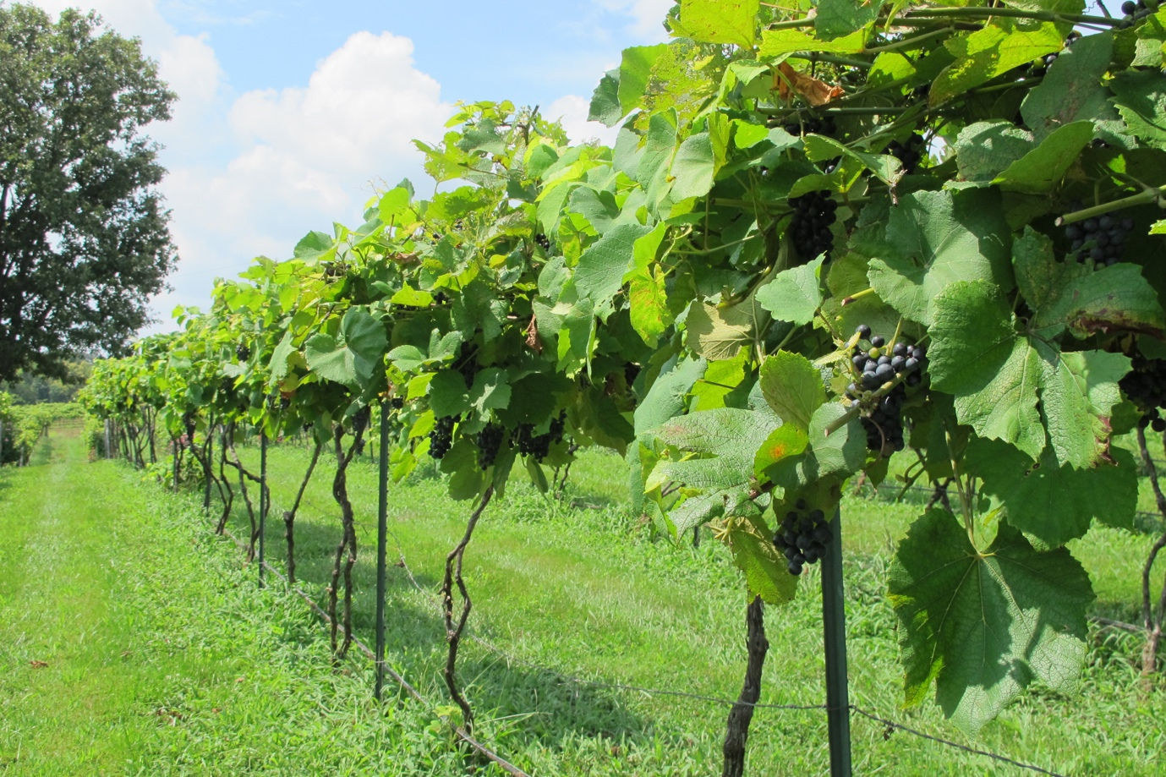

**MISSOURI WINEMAKING SOCIETY APRIL 2024 NEWSLETTER**

**NEXT MEETING: NORTON WINE AND FOOD PAIRING**

**DATE: THURSDAY, APRIL 18**

**WHERE: ST. GERARD MAJELLA MEETING ROOM**

**1971 DOUGHERY FERRY RD.**

**ST. LOUIS, MO 63122**

**TIME: 7:00 PM**

**SUBMITTED BY: Lisa Nordmann**

**MWS WEBSITE:** [**www.mowinemakers.org**](http://www.mowinemakers.org)

**MWS FACEBOOK PAGE**: Missouri Winemaking Society

**MWS INSTAGRAM PAGE**: @mowinemakingsociety

**MISSOURI AMATEUR WINEMAKERS FACEBOOK PAGE**: Missouri Amateur Winemakers

**PRESIDENT’S MESSAGE**: **by Dan Peters**



Hello MWS!  April Showers bring May Flowers, then grapes, then Wine  -  Yeah!  A special Welcome to our new members.  We are eager to jump in with you as you start, or as the case may be, continue your wine making journey.   Reminder – “you can do this” and there is a wealth of experience and resources at MWS to help you along the way.  We look forward to the dazzling, multi-dimensional “John Merkle Norton Experience”, fresh off of a recent world tour.  You know John for his quick wit, mastery of chemistry, and artistic wine making flare.  This month John will take us on a journey of Missouri’s State Grape – Norton.  John will be joined by special guests highlighting the versatility (drink Greg) of Missouri wine paired with food.  We expect a packed house so arrive early for preferred seating 😊.  As the weather continues to warm we look forward to our winery visit in May, details below.  See you soon!  Cheers

**APRIL MEETING: John Merkle will present NORTON WINES AND NORTON WINEMAKING**

The April meeting of the Missouri Winemaking Society will feature a "modified" vertical tasting of Norton wines over many years. John Merkle will present 14 different bottles of Norton ranging from 2002 to 2017 from his collection. There will be no charge for the wines as they are being donated to the club.  
  
Included will be 4 Nortons from Stone Hill, 2 from Noboleis and various other wineries in Missouri, one from Virginia and three J. Merkle wines. John will present a short history of the Norton grape, winemaking techniques with Norton, and tasting of all the wines. Please bring 2 glasses and if you have them, Norton glasses. And for the Foodies! Jeannine and Dan Peters will be providing some wonderful food tastings to go along with John Merkle’s amazing Nortons.

**RE-CAP OF OUR MARCH MEETING – WINEMAKING 101**

Steve Brunkhorst awarded John Merkle with the well deserved award for Favorite Red Wine from our November meeting of Favorite Red Wine Contest. His award winning wine was his 2015 Norton.

Dan Peters headed a round table on Winemaking 101. He gave an introduction on how to get started in red winemaking. He guided us with the help of the online book from MoreWinemaking.com. There is a wealth of info on this site. <https://morewinemaking.com/web_files/intranet.morebeer.com/files/wredw.pdf>

Dan also shared with us his use of a wine journal. You can purchase it here! <https://kegscode.com/product/wine-journal-log-your-wine-recipes-forever/>

Our members joined in the discussion on how they make their red wine. Dan brought some necessary equipment to get started. Many members shared their red wines to taste and explained their winemaking process. It was a very informative meeting and all wines were delicious!

Anne Cath, Cellar Master, put together a list of items she found necessary to begin winemaking. **WINEMAKING supplies (written for red wines)**

Prices are from MoreWinemaking’s website unless noted. <https://morewinemaking.com>

8-10 gallon plastic bucket for fermentation- can use cloth or a cover with airlock. (8 gal. $21.99)

pH meter (Amazon, 11.99)

Potassium metabisulfite powder (6.99)

Tartaric acid (5.99)

Paddle for punching down (4.99)

Hydrometer-to check sugar level/sg, with jar (7.99 with 5.99)

Siphon tubing (3.69)

Clamp for tubing (0.99)

5 gal glass carboy (44.99)

2 x 3 gal glass carboys (2 x 39.99)

1 gal glass jug (8.99)

2 airlocks, 3 piece (2 x 2.99)

2 stoppers or carboy caps with hole for airlock (2 x 1.79)

Oak spirals or staves (12.99)

EasySiphon 3/8”, (10.99)

Used wine bottles, cleaned

Cleaner- OxyClean Free (Schnucks 10.49)

Bottle filler (3.99)

Corks (synthetic 19.99)

Funnels: smaller + large (3.99 + 8.99)

Yeast (3.19)

Malolactic bacteria -Wyeast liquid 4007 (10.99)

(if using dry malolactic bacteria buy ActiMalo to rehydrate it)

Opti-Malo Plus (2.69)

Scale- to the tenth of grams (Amazon 8.97)

Spray bottle for sanitizer

Sanitizer- StarSan or sulfite solution (32 g metabisulfite powder in ½ gallon water)

Ingredient kit: (has Tannin FT Rouge, Go-Ferm, Fermaid K, Lallzyme EX, Opti-Red) (8)

Mesh bags for pressing (2 x 5.99)

_______________________________________________________________________________

**TOTAL** of above items $ 331.38

*Items that are more expensive that you might borrow at the start, or optional but nice to have*

Sulfite tester (Vinmetrica)-can make wine without this (332)

Corker (69.99)

Press- I use a 1.6 gallon fruit press (Amazon 104)

Bottle tree (27.99)

Sanitizer injector (14.99)

**MEET OUR NEWEST MEMBERS**

We welcome our newest members to MWS. It was fun meeting them at our last meeting and look forward to having them in our group.

**Steve Laney** from O’Fallon, MO.

“When Caitlyn and I started dating, we would go to wineries and we always enjoyed it every time we went. That inspired us to start looking into making our own wine and we started looking at areas where we could grow a vineyard. This year, we are growing 2 acres of Norton. Last year, we planted Marquette, Chambourcin, Vidal Blanc, and Cayuga White at our farm up north by Kirksville. We are hoping to open up a winery in the future, but right now we are enjoying learning how to make wine. We have Norton wine in the basement right now and we are planning to make Vignoles and Chambourcin this year”.

**Stuart Galaske**, Dan Peter’s Cousin.

“Born, raised and lived in St. Louis all my life. I am married to Janet for 30 years and we have two adult children Patrick and Mary. My wife will not let me retire, so I recently started working as a Team Leader for the Missouri Army National Guard supporting Missouri Military Funeral Honors.  As introduced by Dan (Peters), I am his cousin and he shared a glass of his Cabernet Sauvignon at our family's St. Patrick's Day party and needless to say I was thoroughly impressed. When he mentioned that he learned how to make it by the guidance of the Missouri Winemaking Society and that they were going to cover the basics at the next meeting I knew I had to attend.  You can say my goal would be to make a comparable batch of Cabernet Sauvignon and I would be happy. I plan to purchase an out-of-the-box kit to get started and work my way up from there. I really enjoyed meeting people at the meeting and was really impressed by the wines that were shared. I am looking forward to the next meeting and starting my journey”.

**Paul Speruzza** from Eureka.

“I am 53 and on sabbatical after a 35 year career in Information Technology.  While looking for the next opportunity, I decided to try my hand at a few hobbies.  One of those was to expand my knowledge of wine which my wife Penelope and I enjoy drinking.  We determined that there is likely no better way to fully understand all the nuances of wine unless we produced some ourselves; thereby being engaged in every step of the process.  Our expectation is to gain knowledge and appreciation for the craft of winemaking.  So far it has been extremely educational.  Additionally, novice winemaking has provided another source of bonding for our family who have all participated in crushing and destemming by hand, as well as sterilization and bottling.  Furthermore, our eldest son has expressed deeper interest in the process and has been involved in literally every step of the way for the 5 batches produced so far.

My wife Penelope and I tend to enjoy semi-dry to sweet wines but decided to produce different types via different ways, again to expand our knowledge, appreciation, and palette.  So far, we have produced the following:

1. Juice Kits
   1. Muscato
   2. Sangiovese
   3. Reisling
2. Raw Grapes
   1. Catawba
   2. Concord

We started last September with the kits and by the end of the month, decided to try our hand at some raw grapes.  When we decided to search for raw grapes, we were referred to 4M Vineyards, who only had Catawba and Concords available.  We have since bottled the kits producing 30 bottles of each.  All turned out very good, with only the Muscato having some impurities in the final product; likely due to that being our first time racking and picking up some sediment.  Day 1 for the Catawba and Concord was September 25th, and they are currently aging in carboys.

We have enjoyed the time and craft of wine-making so much that we are forging ahead to the next step, which is to plant some vines for small production.  We have ordered the following vines which we expect to plant at the end of April:

* Chambourcin
* Vidal Blanc
* Vignoles

Currently, we are investigating how to start a small vineyard, starting with soil testing and other very helpful suggestions from the members of the Missouri Winemaking Society.”

**Steve Rosenberger** a seasoned winemaker is also one of our newest members. My wine making grew out of home beer brewing, which I've been doing  
for maybe fifteen years. Learned to understand wine when I served in Germany for three years in the 1980's.  
Read the book, "Vines to Wines" and decided I could do it! My first wine was a plum wine with our own plums. I had to figure out what to do with 3  
bushels of plums! I was pleasantly surprised with the result, the plum wine is similar to a dry, acidic rose with plum flavor of course. Wish I had  
joined the Missouri Wine Making Society sooner, could have learned valuable lessons. My next  move was to contact you, and you gave me Jacob Schneiders  
name. He invited to his vineyard and I helped him harvest. He encouraged me start practicing making wine with some of his grapes before my crop comes  
in. So, my first wine was a 2021 Norton. I wanted to let some of it bottle age a little longer but my youngest daughter got married last year and the  
last cases were drank at the wedding! I just bottled 2022 Chambourcin (Jakesgrapes again).  
  
I am currently growing 30 vines at our north county home and will be planting 30 more this April. My vineyard will have St. Vincent, La Cresent,  
Brianna, Ives, and hopefully some grafted Norton. My wife, Sherrelyn, helps a little with the vineyard but is not a huge wine fan.  
  
Favorite wine: Anything that goes with Pizza!  
  
My viticulture advice: buy from known, trusted, experienced, honest  
sources!!

**MAY 11 WINERY TOUR AND WINE TASTING AND PICNIC**

Our annual wine tour and picnic will be on May 11 at Robbler Winery. We will meet at Robbler Winery 275 Robbler Vineyard Rd, New Haven, MO 63068. <https://www.robllerwines.com>

We will meet at the winery at 11:00 and start off with a tour of his winemaking facility and then have a private tasting. Picnic lunches are welcome. There is snacky type of food there but no lunch menu.

**CONGRATULATIONS TO GREG STRICKER**

Congratulations to Greg Stricker for his medal wins at the [TVOS - TN Viticultural and Oenological Society](https://www.facebook.com/groups/TnVOS/?__cft__%5B0%5D=AZV89NAkeUsSgsfGDpJ14sZzF7cWvUmGAyLOZzN1qcTE-ZBmamrVf0AsFcwvmznUyGrZ3GoElRLakIrT_Zh9DxlZ_c6ER7nxdMfcJ_nL6AcRZYH5VU9BwSQ-EUbSjk0689_BWlHRx71hLzhAF0f-swsB0aFCD7KE33SmwmDwwOXMF-_IsQTJ3mMmP4OnoJrk0Vk&__tn__=-UK-R) Wine Competiton.

Best Dry White wine: 2022 Viognier.

Gold: 2022 Viognier, Vignoles, Chardonel & 2020 Norton Port.

Silver: 2022 Traminette & Seyval, various Nortons & Chambourcins.

Bronze: Black Raspberry.

**DANIEL PAMBIANCHI: NEW BOOK AND WEBINARS**

Wine Guru – Daniel Pambianchi just published his new book for Beginning Winemakers. Here is the link to order it. <https://techniquesinhomewinemaking.com/beginners-guide/> It can also be ordered on Amazon. Here is a synopsis of the book.

From the author of *Modern Home Winemaking* and *Techniques in Home Winemaking*, **Daniel Pambianchi’s** *The Beginner’ s Guide to Making Wine from Juice and Grapes* is for novices keen in making their own wine at home. It guides aspiring winemakers through the process, from crush to bottle, with step-by-step instructions using simple, modern techniques to craft consistently great wine. The book includes many illustrations, tables and examples to highlight the use of equipment and tools, and a comprehensive chapter dedicated to solving common winemaking problems.

Also, Daniel has very informative webinars. They are only $9.95 if you view them live. After the webinar he will answer questions. If you can’t view them live, they are available for $4.95. I have viewed every webinar and have learned so much.

**Daniel’s Website is full of information. Check it out at** <https://techniquesinhomewinemaking.com>

**YEARLY DUES ARE DUE**

Our yearly dues of $50 is now due. Please bring a check made out to Missouri Winemaking Society to the January meeting and give it to Dave Wert. You can also mail it in to Dave Wert, 1599 Highway 100, Pacific, MO 63069.

**ENJOY THE PICS FROM OUR MARCH MEETING**

